The official handbook for competitors and riders of JEA

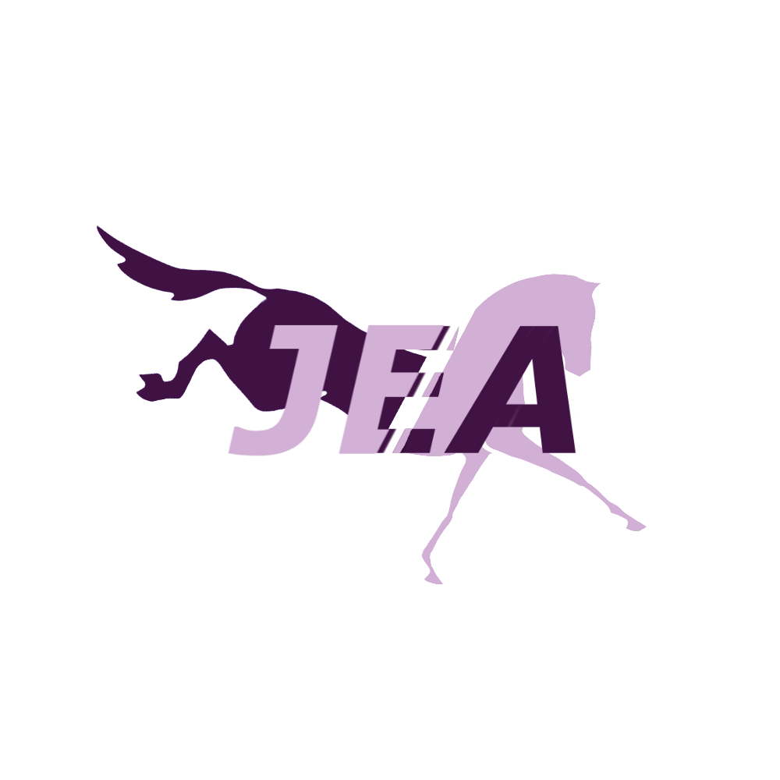
Disclaimer: The information found in this handbook is for the use of JEA competitors only. It contains explanations and regulations specific to the Jorvik Eventing Association, and should not be used outside of the server.

Utilize the table of contents to help you find your way!
♠ Table Of Contents ♠

- General Rules
⋅ An explanation of our server rules and specific regulations that apply during competition
- Competition Overview
⋅ Entering a competition, registration of rider/horse, schedules, show levels, and other important competition-related information
- Levels of Competition
- Scoring
⋅ Further explanations of each event and scoring-related info
3a. Dressage points/penalties
⋅ Includes judge’s ideals and breed scores
3b. Cross country penalties
3c. Show jumping penalties
- Terminology
⋅ Detailed descriptions of gaits, competition terms, and diagrams
- Dress Code
⋅ Required attire for each event
- Championships
〰️ General Rules 〰️

￫ Discord Server Rules
- Competitors must be at least 13 years of age
⌁ The discovery of a member younger than 13 will result in an immediate kick
- All Discord Terms of Service and Community Guidelines must be followed by members at all times (https://discord.com/terms)
- Discussion of sensitive or triggering topics of any sort is not allowed. This includes (but is not limited to) abuse, religion, politics, self-harm, discrimination, etcetera.
- All media sent within the server must be appropriate (SFW). Absolutely no explicit, violent, sexual, or (in other ways) irritable content
- Conversation should be kept PG-13. Cursing is allowed in mild contempt, but never in a way directed towards others
Ie: “Damn it, I totally flunked that course” VS “F*** you”
- There is a Zero-Tolerance policy for drama of any sort
- General respect to judges, officials, and other competitors is essential to maintain a community environment. Scores are final and should not be argued (you will receive your dressage test back from the judge to review your results, but no attempt to sway a numeral amount is allowed)
- Spamming of any kind within the channels will result in a ban, kick, or other consequence depending on the circumstances (Including pings ￬)
- Excessive pinging of competitors or staff members is not allowed. Certain situations permit a ping. Ie: @eventofficial “I apologize for the ping, but my game froze and will not be able to complete my round…” VS @stormy @stormy @stormy “My wifi crashed let me retake.”
- Please do not directly contact our staff. You may have a ticket to report misconduct/discuss sensitive topics, but keep other questions in the #questions channel (not in our Staff members’ DMs!!!)
- In the #questions channel, please refrain from answering any questions. They should only be answered by staff members, as we do not want misinformation being spread
- Any attempt of cheating or bribing to influence a score or other aspect of competition is not allowed
- All property of JEA must remain within the server and is not to be used by any outside group/individual for use of any kind unless they have received an exception. This includes ribbons, courses, information, server layout, etcetera
⌁ The direct and international ignorance of the listed (or generally implied) rules may result in a warning or server ban directed by the HRs and Staff members.

￫ Competition Rules
- Competitors must be a registered rider and enter on a registered equine in order to compete at recognized shows
- Competitors should remain on mute throughout the entirety of the competition, unless using vocal confirmation during the check-in (jog)
- Horse and rider must remain in the waiting/warm-up area until their turn has begun. Entering the show arena during another rider’s course may result in disqualification
- Individuals must register for shows which they meet the requirements for. (To learn more about level requirements and MRs go to the “Competition Overview” section in the JEA ~ Competitor Handbook)
- General sportsmanship and manners must be presented by competitors
- Repetitive “No-shows” (Registering for a competition, then not presenting oneself during the check-in period) will be placed on a temporary ban from showing. An infraction will not be assessed to competitors who fill out the scratches form >1 hour before the start of a competition
⌁ Disobedience of these competition rules may result in penalty points or disqualification to be assessed to the competitor in accordance to the severity of the infraction

〰️ Competition Overview 〰️

￫ Competition Entries
- Prior to the start of a competition (usually ≃ 2 weeks) a Google form will be released. You may apply through this entry form to be put on the competitor/waitlist.
- As stated per our competition rules, pairs must be registered and meet the requirements of the level/competition that they enter
￫ Rider & Horse Registration
- In order to register yourself or your horse(s) with the Jorvik Eventing Association, you must fill out the registration form attached in the #important-links channel (and on the JEA website)
- To view which riders and horses have been registered, look at the spreadsheet attached below the registration form (it is also found on the JEA website)
- By registering with JEA, we have pre-submitted information about competitors and horses. The registered rider/horse list resets yearly
￫ Showing Schedules
- Specific information about timing, date, locations, and courses of each event vary depending on the show
- There are 3 different formats: Long, Short, and Modified
- The basic order of events at a horse trial is…
⌁ Check-in (Jog) ￫ Dressage ￫ Cross Country ￫ Show Jumping ￫ Awards

〰️ Levels of Competition 〰️

- Competition levels determine the height, speed, and technicality of jumps, while also increasing the difficulty of a dressage test
- Competitors must obtain a specified amount of MERs before moving on to the next level of competition
- In real life, eventing has much more fluctuation between each level. JEA divides and mixes these levels to provide opportunities for each group of competitors

⌁ Novice
This is the most elementary level of competition. Dressage tests are simple and jumping courses are introductory. Any registered rider and horse may participate in a novice-level competition with no prior experience.
⌁ Preliminary
This is the secondary level of competition. Dressage tests have increased difficulty and jumping courses have increased difficulty. Rider and horse pairs must have obtained at least 1 MERs at the novice level.
⌁ Advanced
This is the most advanced level of competition. Dressage tests are extremely challenging and jumping courses are not for the faint of heart. The rider and horse pair must have obtained at least 2 MERs at the preliminary level.

See “MER” in the Terminology category
Specific Regulations Per Level
 | Novice | Preliminary | Advanced
Dressage movements | Halt at X, walk, trot, canter, long diagonal, 20m circles, 2 loop serpentine | Halt at D, X, or G, walk, trot, canter, long & short diagonal, extended canter, 20m circles, 15m circles, 2 & 3 loop serpentine | Halt at any letter, back up, walk, trot, canter, long & short diagonal, extended canter, 20->5 m circles, half circles, up to 4 loop serpentine, walk > canter transition
XC regulations  (Maximums) | Speed: 350 mpm (extended canter)  Distance: 1500 m  Time: 4:30 seconds  Efforts: 15 | Speed: 425 mpm  (slow gallop)  Distance: 2250 m  Time: 5:15 seconds  Efforts: 20 | Speed: 500 mpm  (fast gallop)  Distance: 3000 m  Time: 6:30 seconds  Efforts: 25
SJ regulations  (425 max for ALL LEVELS) | Total Fences: 10  1 strides: 0  2 strides: 2 | Total Fences: 12  1 strides: 1  2 strides: 2 | Total Fences: 15  1 strides: 2  2 strides: 2

It is important to note that all riders are restricted to the slow gallop (5 up from the halt) while in SJ. Couses consist of many tight turns and combinations, and it is unsafe to run full speed at these obstacles.
To clarify, all optimums in SJ will be taken from the course ridden at 425 mpm (slow gallop) + a few courtesy seconds.

〰️ Scoring 〰️

￫ Overall Scoring
In eventing, the score that you finish on is the number of penalties that you accumulated throughout each phase. For example, if I earned a 80/100 on a normal dressage test, It would become 20 penalties since that is the number of points that I missed. If I were to accumulate 40 penalties on cross country (2 refusals), my score would become 60 penalty points (aka faults).

￫ Dressage Scoring
In JEA, dressage judges are trained to evaluate how well you complete a specific movement (1-10 points). They look for…
- Smoothness > How did you complete the transition? Did the horse veer off course/competitor lurched the horse to one side, did the figure look out of place in the arena, or did these things blend?
- Straightness > Did the horse veer off course during a “Trot down the long wall,” did the player need to readjust during a diagonal?
- Timing > Where was the movement completed? Did the transition occur early, late, or on time? (Hint: Practice transitioning and taking into account the screen delay)
- Geometry > Was arena usage even? Did the rider move the horse into the corner, were the circles balanced?

￫ Dressage Penalties
- Exiting the arena before the final salute > Disqualification
- Entering the arena before a judge says to begin > Disqualification (or under certain circumstances, a number of penalties may be given)
- Delaying test start time > Disqualification (Explanation: Riders must enter the arena at ‘A’ before the passage of 45 seconds since the judge said to begin.
- Improper attire > Depending on the severity of the infraction, a number of penalties will be given
- Incorrect movement > Judges will give penalties accordingly for a mistake in the transition/figure, but depending on how it affects the flow of the test (turning the wrong way will make the entire test dysfunctional) a rider may be disqualified (see below)
- Unhappy > 2 penalties will be given for every level below the happiest
- Low level > 2 penalties will be given for every level below 15
- Breed > Certain breeds will receive penalties, see “breed scores”

In the instance of an incorrect movement that disrupts the entire test, a rider may be given grace (at a local-level competition). The rider will be moved down 2 places in the order of go, and in the meantime may study the dressage test. They must pick up the test from the point where the error occurred, and scores from previous movements will remain. 60 penalty points will be assessed to the rider.

￫ Breed Scores
Breed scores evaluate the movement/carriage of a horse. These scores are used in a dressage test. Horses from generations 1-2 are not permitted. Magical horses/coats are not allowed in competition.

Akhal-Teke > 8
American Paint Horse > 10
American Quarter Horse > 8
Andalusian > 10
Appaloosa > 10
Arabian 10
Belgian Warmblood > 10
Chincoteague Pony > 8
Clydesdale > 6
Connemara > 10
Curly Horse > 6
English Thoroughbred > 10
Finnhorse > 10
Fjord Horse > 8
Gotland Pony > 10
Haflinger > 10
Icelandic Horse > 10
Irish Cob > 6
Jorvik Friesian > 6
Jorvik Starter Pony > 4
Jorvik Warmblood (Or Starter horses) > 10
Jorvik Wild Horse > 6
Knabstrupper > 6
Lippazaner > 6
Lusitano > 8
Marwari > 8
Morgan > 10
North Swedish Horse > 6
Paso Fino > 8
Percheron > 6
Shire > 6
Tennessee Walking Horse > 8
Trakehner > 10
Welsh Pony > 10

￫ Cross Country Scoring
Jump judges will follow you throughout the course. The goal is to accumulate as few penalties as possible
- Optimum time > The goal on XC is to be as close to the given time as possible, without going over. The optimum time is determined by the speed of each level (IE: If a novice rider were to maintain an extended canter for the entire trip, they would be very close to optimum)
- Speed penalties > 2 penalties for each second under the minimum time. Each level (Novice, Preliminary, Advanced) has a designated speed that riders are encouraged to maintain. For example, a novice rider’s optimum is 350 meters per minute. If they were to ride at 500, they would be much faster than the minimum allowed time.
- Time faults > 2 penalties for each second over optimum time
- Refusals > 20 penalties per refusal (stopping, walking, or trotting before an obstacle) 3 refusals result in an elimination
- Off-course > Disqualification (forgetting an obstacle and continuing to the next without noticing, veering far off the designated path)
- Circling/changing speed between the final 3 fences/finish line > 20 penalties (When riders have gone too fast/slow during their round, they may not attempt to make optimum by circling, slowing down, or speeding up) Riders must remain in the same gait until the finish
- Circling on-course > Circling on-course is allowed, as long as the rider is at least 8 strides out from the nearest obstacle. Otherwise, the circle will be classified as a refusal

￫ Show Jumping Scoring
The course will usually be released on the morning of SJ day
- Optimum time > The goal in SJ is to be under the optimum
- Time faults > 2 penalties for each second over optimum time
- Refusals > 8 penalties per refusal (stopping before an obstacle) 3 refusals result in an elimination
- Off-course (and circling) > Disqualification
- “Dangerous Riding” > 5 faults per second at the fast gallop gait
- “Knocking a rail” > 4 penalties (If a rider drops to a canter or below after completing a jump)
〰️ Terminology 〰️

- “Attire” > The clothing and tack worn by competitors
- “Dangerous Riding” > A penalty that is administered to individuals who ride at a fast gallop during a show jumping course
- “Dressage Test” > An organized list of movements and transitions that riders must complete in a standard 20 by 60 dressage arena
- Gaits
 | Walk | Trot | Canter | Extended Canter | Slow Gallop | Fast Gallop
From halt | 1 up | 2 up | 3 up | 4 up | 5 up | 6 up
Speed | X | X | X | 350 mpm | 425 mpm | 500 mpm
- “Happiness” > The horse’s mood. Vivid green (full bar, very happy) receives no penalties. Each mood below happy results in 2 penalties
- “Horse trial” > An eventing competition
- “JEC” > Jorvik Eventing Championships
- “Jogs” > A check-in period that occurs before the show. Competitors will be marked present (or truant if they are missing). The horse’s mood and level “Soundness” will be evaluated at this time
- “Jump judge” > A staff member that will follow you during your XC/SJ course. They add up penalties and track your time
- “Knocking a rail” > Dropping to the canter or below during a Show Jumping course, results in 4 penalties (aka hitting a jump)
- “Local show” > Defines a competition that may help qualify competitors for championships
- “Long Format” > (3-day event) A show where each event occurs on a different day
- “MER” > Minimum eligibility requirement {A score of no more than 40 penalties in dressage, no XC penalties, and less than 12 penalties in show jumping}… Before moving to the next level, competitors must achieve a certain number of MERs
- “Modified Format” > A show where 2 events occur on one day, and the other occurs on the next day
- “MPM” > Meters per minute, referring to the speed being traveled by a competitor on a cross country course
- “Optimum time” > Refers to the max amount of time (specific to competition level, speed, and distance) a rider may reach before receiving penalties. In the case of a tie, the rider who is closest to optimum (without going over) will be deemed as the winner
- “Registered” > Defines a rider or horse who is registered with the Jorvik Eventing Association
- “Short Format” > A show where all 3 events occur on the same day
- “Soundness” > The horse’s mood and level. This is sent to the dressage judge to apply to the dressage test score
- “Speed penalties” > Penalties received by competitors who go too fast (are under the minimum time) on a cross country course
- “Time faults” > Penalty points added to competitors' score due to exceeding the optimum time
- “Truant” > The term to define a competitor who does not show up during jogs (check-in). 1 truancy will result in a 2-show ban from competing. 2 truancies will result in a ban from showing in any/all competitions throughout the year.

￫ Dressage Test Movements
- Long diagonal > From F-H or K-M
- Short diagonal > From F-E, K-B, H-B, M-E
- “Simple change” > A lead change that occurs over the course of 4-6 trot steps, with a slight bend in the new lead’s direction
- “Flying change” > A change in canter leads (Since SSO horses can not change leads, it is indicated by a change in bend [IE: On the left lead, you may tap your left key to have a left bend])
- 20-meter circle > A circle that is the full width of the arena
- 15-meter circle > A circle that is ¾ of the width of the arena
- 10-meter circle > A circle that is ½ of the width of the arena
- 5-meter circle > A circle that is ¼ of the width of the arena
- 2 loop serpentine > Start at one of the end letters (A or C), pass through X, change direction, and finish going the opposite direction at the opposing end letter
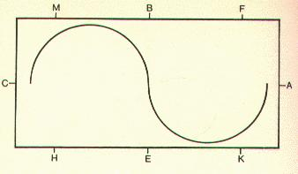
- 3-loop serpentine > Similar to a 2-loop serpentine, but riders should pass to the inside (closer to X) of the invisible letters L and I. Competitors will finish heading in the same direction that they started
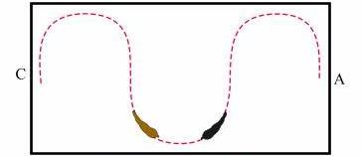
- 4-loop serpentine > Riders should pass to the outside of the invisible letters L and I, and through the letter X. Competitors will finish heading in the same direction that they started
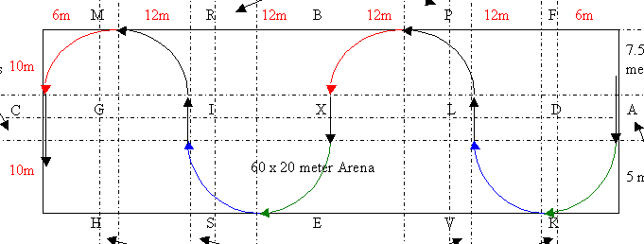

〰️ Dress Code 〰️

￫ Dressage Tack (Equine)
- Brown or black English snaffle bridle with a cavesson, flash, or dropped noseband
- Plain brown or black dressage saddle
- Large white saddle pad
- No leg protection
- Tail bows may be used for indication (see diagram)
- No mane bows
- Mane must be plaited or in button braids
- No saddlebags/pets
￫ Dressage Attire (Rider)
- Black or navy show coat
- Tan, beige, or white breeches
￫ Riders competing at the advanced level must wear white breeches
- Plain brown or black tall boots
- Full-length black or white gloves
- Black helmet (Top hats are not allowed)
- Hair in a bun (tucked under helmet)
￫ Short bob with sidecut, short bob cut, short wavy bob cut with bun, spiky punk, short bob cut with short ponytail, bangs with pigtails
- Permitted: Minimal jewelry, glasses

￫ Cross Country Tack
- Brown or black English snaffle bridle with a cavesson, flash, or dropped noseband
- Plain brown, walnut, chestnut, or black close-contact (jumping) saddle
- Any color english (short or large) saddle pad
- Jumping boots (polo wraps are not permitted)
- Tail bows may be used for indication (see diagram)
- No mane bows
- Mane must be in a short, neat, style (button braid, pulled, roached)
- No saddlebags/pets
- Horseshoes are strongly recommended
￫ Cross Country Attire
- Cross country shirt + vest (any color)
- Tan, beige, black, gray, or white breeches
- Plain brown or black tall boots
- Long gloves > black, brown, or white
- Helmet > any color (cover) is allowed
- Hair tied back
￫ Any of the permitted hairstyles for dressage, all low ponytails, pigtails, and braids
- Permitted: Minimal jewelry, prescription glasses
- No masks or covering/paint of the rider’s face

￫ Show Jumping Tack
- Brown or black English snaffle bridle with a cavesson, flash, or dropped noseband
- Plain brown, walnut, chestnut, or black close-contact (jumping) saddle
- Any white English (short or large) saddle pad
- Jumping boots > optional (polo wraps are not permitted)
- Tail bows may be used for indication (see diagram)
- No mane bows
- Mane must be in a short, neat, style (button braid, pulled, roached)
- No saddlebags/pets
￫ Show Jumping Attire
- Any color show jacket
- Tan, beige, or white breeches
- Plain brown or black tall boots
- Full-length gloves > black, brown, or white
- Helmet > black or brown
- Hair tied back
￫ Any of the permitted hairstyles for dressage, all low ponytails, pigtails, and braids
- Permitted: Minimal jewelry, prescription glasses
- No masks or covering/paint of the rider’s face

￫ “Jogs”
- Brown or black English snaffle bridle with a cavesson, flash, or dropped noseband
- Horses must not have tack of any sort (other than a bridle). This includes a saddle, pad, boots, or mane bow
- Tail bows may be used for indication (see diagram)
- Mane must be in a short, neat, style (plaited/button braids)
- Rider should be in neat, formal attire with tall boots and a helmet

Ribbon/Tail bow Chart
Color | Definition
Red | “This horse kicks!”
Green | Young/Inexperienced Horse
White | For Sale
Yellow | Stallion

〰️ Championships 〰️

￫ Overview
The Jorvik Eventing Championships occur at the end of each year. Competitors (horse and rider pairs) may qualify by reaching a certain amount of accumulated points at novice, preliminary, or advanced. Since the competition is much stiffer, all courses have increased difficulty.
The following sections depict the differences in local > champs
￫ Competition Classification
In real-life eventing, international-level competitions are classified as CCI (1-5)* Since our competitions are currently only held across the island of Jorvik, in the North American region, they are classified as CCJs (Concours Complet Jorvik). We have 3 different “championship” levels; 1* “star,” 2*, and 3*. The JECs are much more prestigious and are governed as such.
￫ Qualification
Riders receive a certain amount of points (depending on the number of people in the class and their place) for competing in a competition.
- CCJ 1* > To compete at the JECs in the 1* (novice) level, a rider and horse pair must have won first, second, or third place at a novice competition, or accumulated at least 30 points at the novice level
- CCJ 2* > To compete at the JECs in the 2* (preliminary) level, a rider and horse pair must have won first, second, or third place at a preliminary competition, or accumulated at least 25 points at the preliminary level
- CCJ 3* > To compete at the JECs in the 3* (advanced), a rider and horse pair must have won first, second, or third place at an advanced competition, or accumulated at least 20 points at the advanced level

￫ Dressage
- Judging > Riders will be scored by two judges (one of our own + a visitor judge), and the score will be averaged. The scoring factors (straightness, alignment, timing, geometry) stay the same
- Tests > Each level will have a new test
- Attire > The requirements for tack and attire do not change, but competitors are recommended to wear the best version of every item

￫ Cross Country
- Judging > Riders will be followed by one jump judge, but their time will be taken by 2 timers (one at the start and one at the finish line)
- Course > Courses at each CCJ level will be maxed out (difficulty, obstacles, speed, length). A course walk and map will be posted

￫ Show Jumping
- Judging > Riders will be timed by 2 different judges, their time being averaged
- Course > A course map will be posted in the discord server, and an official course walk will start at the specified time
￫ Ceremonies
- Competitor banquette > A celebration of the year and individual achievements that will occur after cross country (attendance is optional). There will be games, races, and other fun activities
- Awards > Ribbons will be awarded immediately after the placings are calculated. Results and scores will be announced live in the voice call. There will be a victory lab for each level.

￫ Prestige
Specific features are included in the JECs to add to the prestige factor
- Spectators > The JECs are advertised in many different discord servers and on our social media. Spectators are welcomed to the live show
- Live Stream > All 3 phases (and the award ceremony) will
- Ribbons > Special (big) ribbons are awarded to the top placing riders

This handbook is the official property of Anne Stormside. It should not be used by anyone for any purpose other than eventing within the JEA server.

